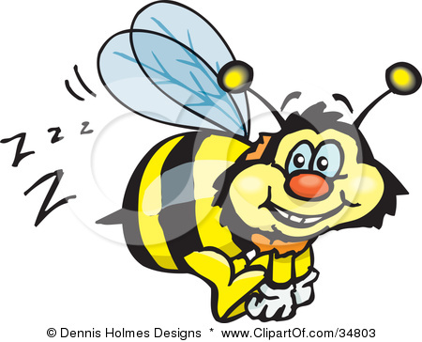
Sounds
The loudest sound in the world must be
An earthquake on top of me!

The saddest sound in the word must be
Me getting stung by a bee.

The happiest sound in the world must be
A million people drinking some tea.

The funniest sound in the world must be
My mammy and daddy up a tree.
By Arron O’Brien

