Sounds
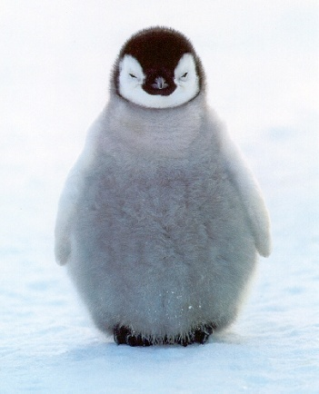
The happiest sound in the world must be
My friend and I playing the Wii.

The jolliest sound in the world must be
Somebody laughing up in a tree.

The craziest sound in the world must be
A penguin and I slurping up tea.

The saddest sound in the world must be
Mam and dad shouting at me.

By Chloe Heavin.

