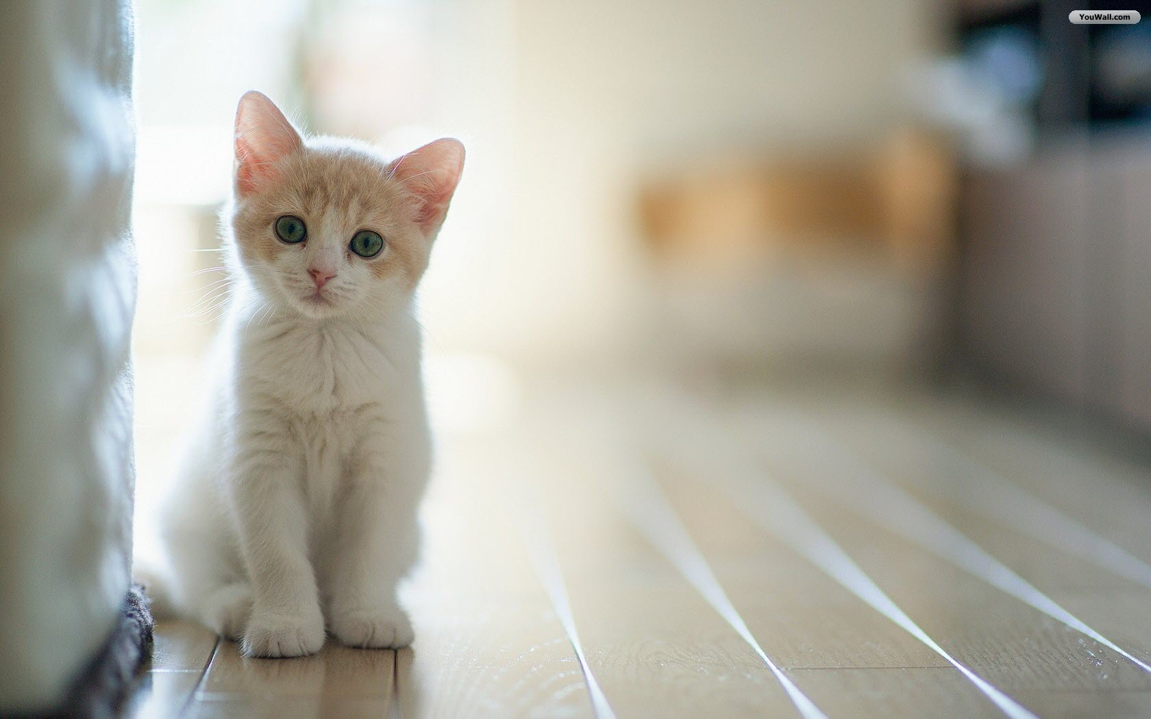
Sounds

The quietest sound in the world must be
A little bird singing proudly at me.

The loudest sound in the world must be
Thunder flashing over the sea.

The nastiest sound in the world must be
A dog barking loudly at me.

The happiest sound in the world must be
A tiny kitten drinking his tea.

By: Helen Lynch

