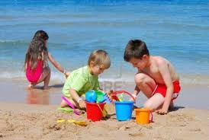
Sounds

The happiest sound in the world must be
Children playing with me.

The saddest sound in the world must be
Someone crying when they fall off a pony.

The quietest sound in the world must be
An ant slurping his tea.
The loudest sound in the world must be
third class talking over me.
By Mary Tyrrell

