Sound
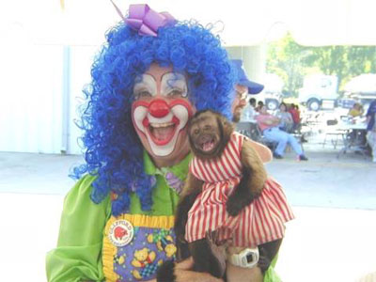
The loudest sound in the world must be
A child slurping his very hot tea.

The craziest sound must be
Me swinging in a high, high tree.

The angriest sound in the world must be
My mum and dad giving out to me.

The funniest sound in the world must be
A clown & monkey laughing at me.
By Oisin Murray Gaffey

