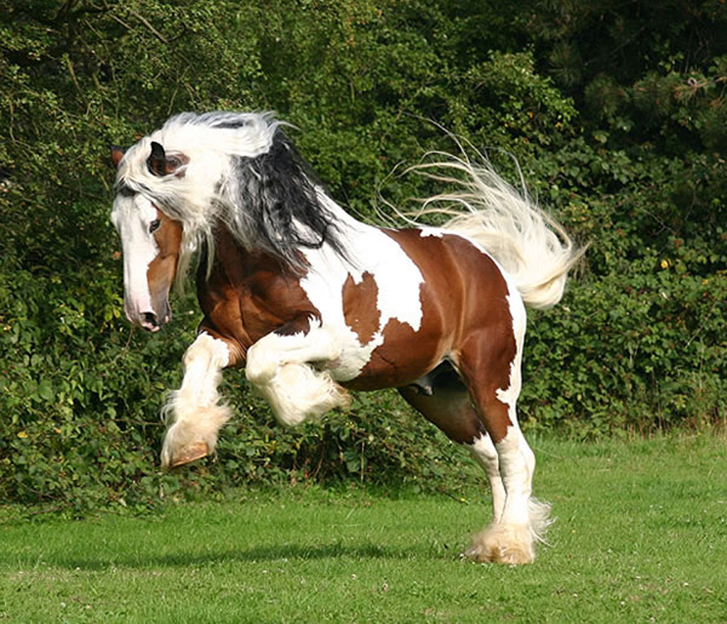
Sounds
The funniest sound in the world must be
A pony singing happily.

The happiest sound in the world must be
Little kids playing happily.

The angriest sound in the world must be
People shouting angily.

T he loudest sound in the world must be
3rd class talking over me.

By Sophie Ellen Grouden

