Sounds
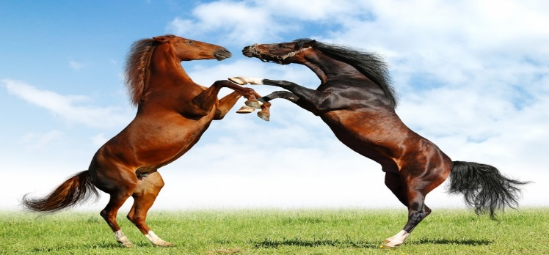
The nicest sound in the world must be,
Me getting something free.

The worst sound in the world must be,
A girl slurping very hot tea.

The smallest sound in the world must be.A bee buzzing in a tree.

The loudest sound in the world must be,
My mam and dad winning the lottery.

By Anna Cornally

