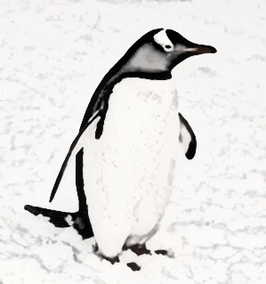
Sounds:

The happiest sound in the world must be
The birds and I singing in the tree.

The jolliest sound in the world must be
A penguin and I slurping up tea.

The saddest sound in the world must be
A baby crying for its mammy.

The nastiest sound in the world must be
A person laughing straight at me.

By Anna Sheerin

