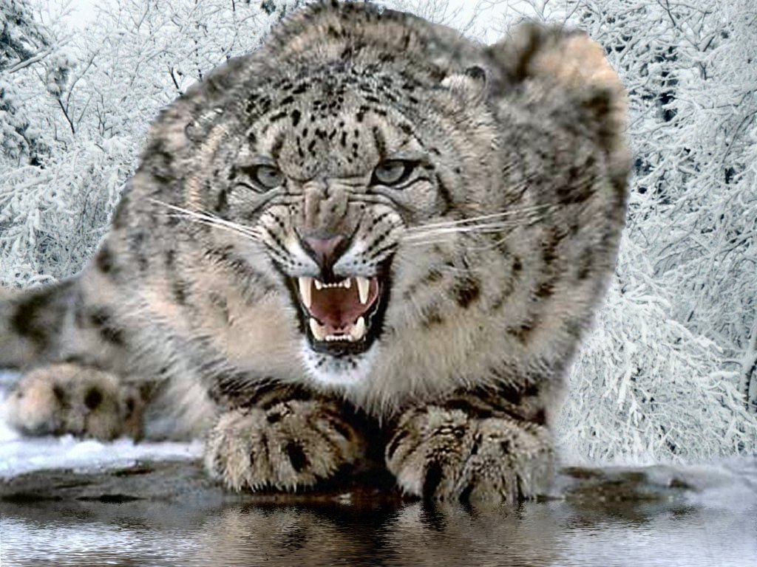
Sounds
The wisest sound in the world must be,
An owl hooting at the top of his tree.

The happiest sound in the world must be,
Some birds chirping in their tree.

The loudest sound in the world must be,
A whale humming at the bottom of the sea.

The quietest sound in the world must be,
Some snow leopards lazing under a tree

By Corey

