Sounds
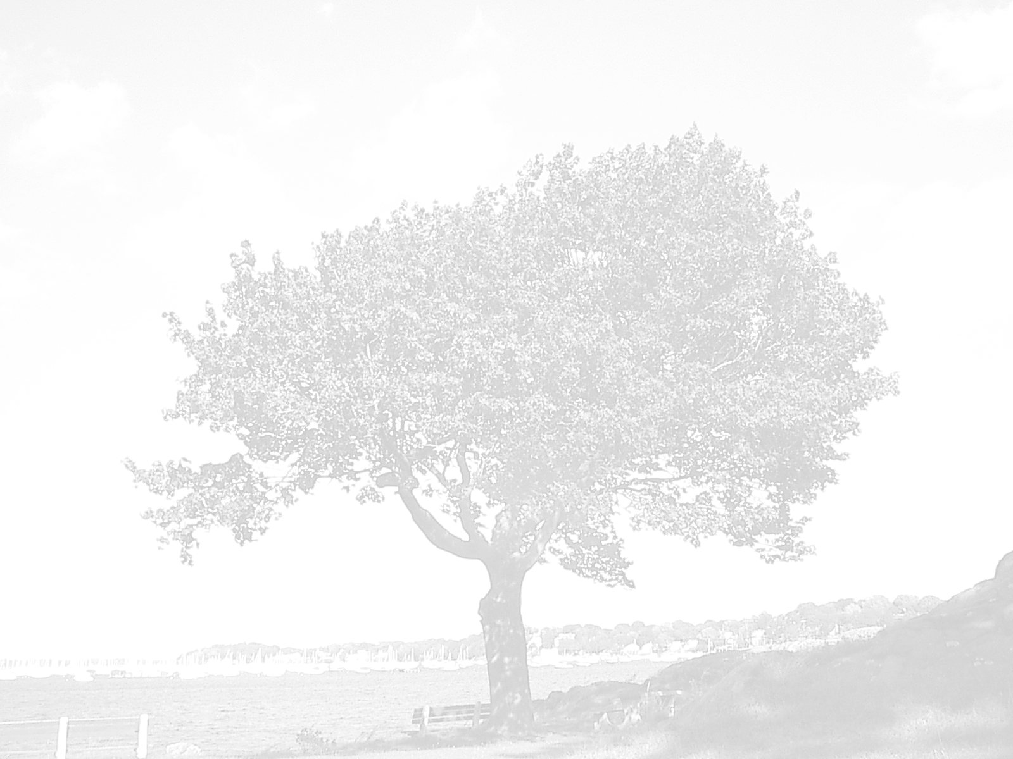
The craziest sound in the world must be
When my little brother turns up the TV.

The most annoying sound in the world must be
When my cousin yells loudly at me

The cutest sound in the world must be
My baby cousin saying Davy.

The strangest sound in the world must be
The yells from the huge forest tree.

Davy Hackett

