Sounds
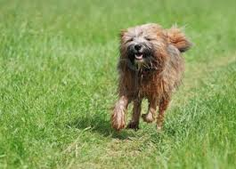
The smallest sound in the world must be,
A baby mouse squeaking with glee.

The loudest sound in the world must be,
An elephant jumping into the sea.

The happiest sound in the world must be,
A dog after receiving a bone from me.

The quietest sound in the world must be,
Me happily playing with my puppy.

By: Emma Dickson

