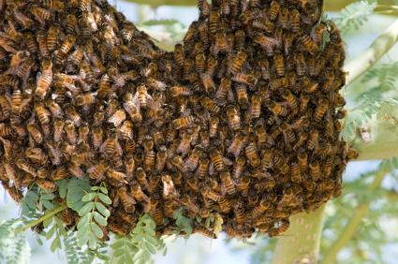
Sounds
The craziest sound in the world must be
A monkey swinging in the tree.

The saddest sound in the world must be

Someone losing the lottery.

The quietest sound in the world must be

A busy bee buzzing in the tree.

The loudest sound in the world must be
a lion roaring happily.

By Evan Daly

