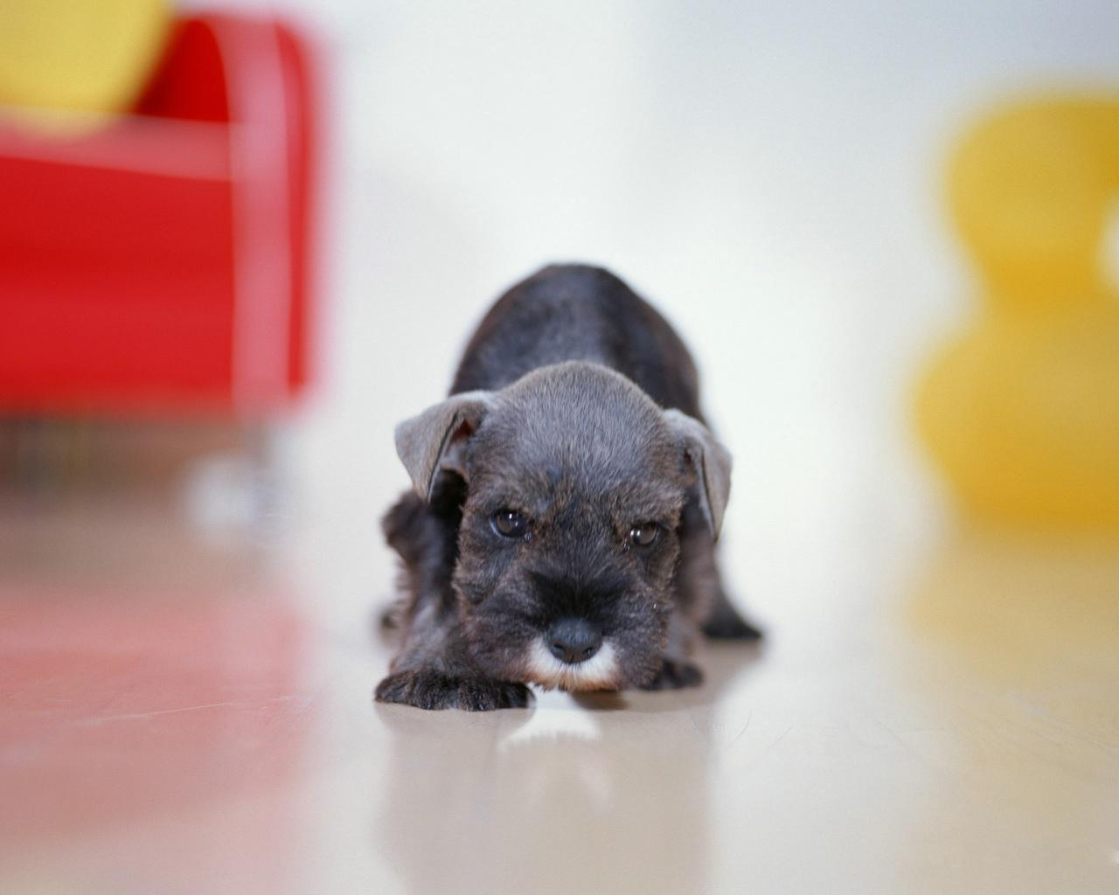
Sounds:

The noisiest sound in the world must be
My dog barking loudly at me.

The loudest sound in the world must be
Dylan and I being noisy.

The angriest sound in the world must be
Mammy & Daddy shouting at me.

The silliest sound in the world must be
La LaLaLaLaLa Yippeeeeeee!

By: Lucy Nicole Egan

