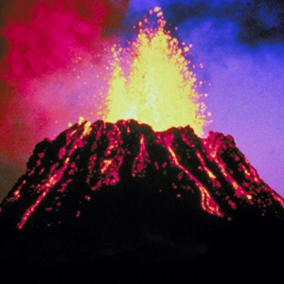
Our Volcano Experiment
Team A:
Aimee, Lucy, Eliza Jane, Rachel and Lia.

Equipment:
Baking soda, vinegar, paint, funnel, glass jar, jug, spoon

Method:
Step 1: Lia put the glass jar into the jug.
Step 2: Lia put the funnel into the jar.
Step 3: Eliza Jane put the baking soda in through the funnel into the jar.
Step 4: Aimee and Rachel put the red and orange paint into the jar.
Step 5: Lucy put the vinegar into the jar.
Step 6: THEN IT ERUPTED!!!

Results:
When it erupted the magma bubbled up and it turned into lava.
We did this to represent a real VOLCANO.

