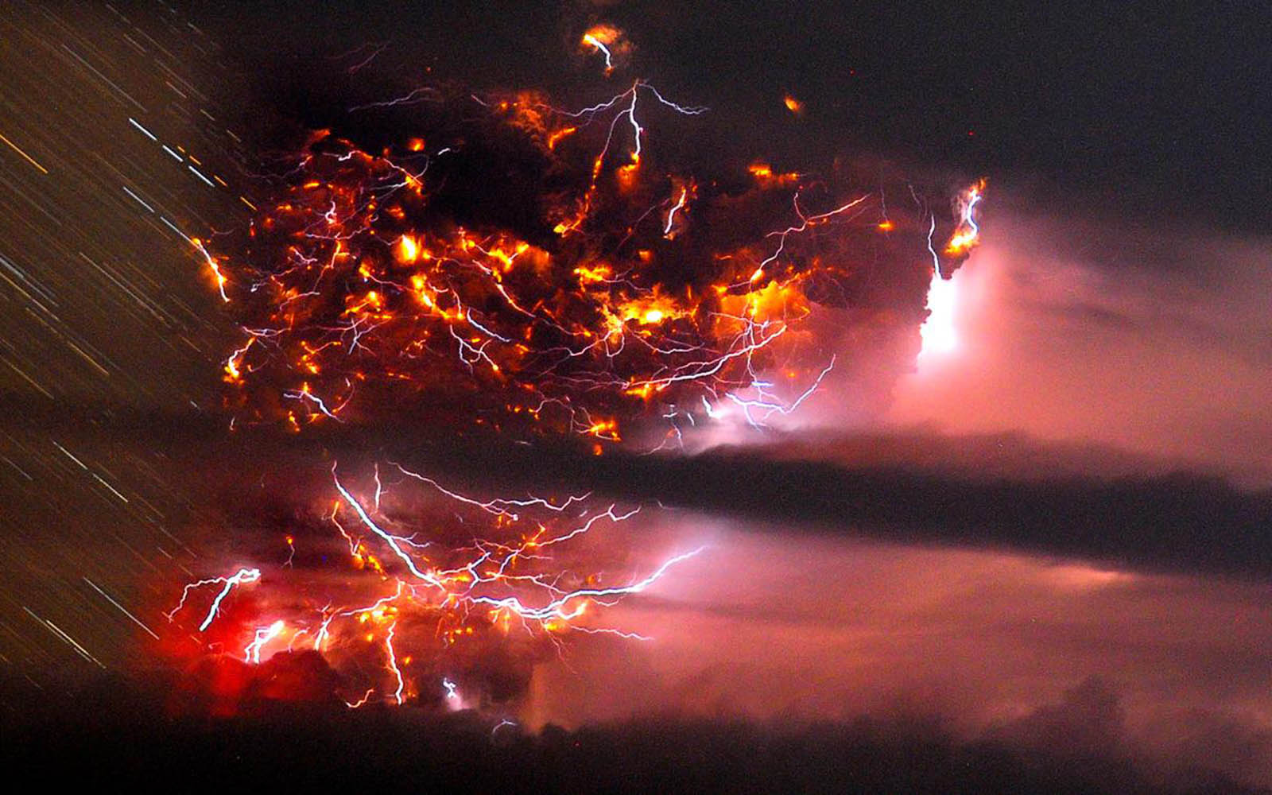
Our Volcano Experiment
Team E: Rory, Corey, Evan and Arron
Step 1: Put the jar into the centre of the jug
Step 2: Pour the baking soda into the jar using a funnel.
Step 3: Take the funnel out of the jar
Step 4: Pour a little bit of paint /food colouring into the jar
Step 5: Pour vinegar into the jar enough to make it erupt
Step 6: Have fun and watch your master piece erupt
You Will Need: baking soda, vinegar, paint, paintbrush, funnel, jug and jar
Result:
BOOOOOM!!!!
When the liquid was inside the jar it was magma, when it erupted it was lava. The jar was representing a volcano.

