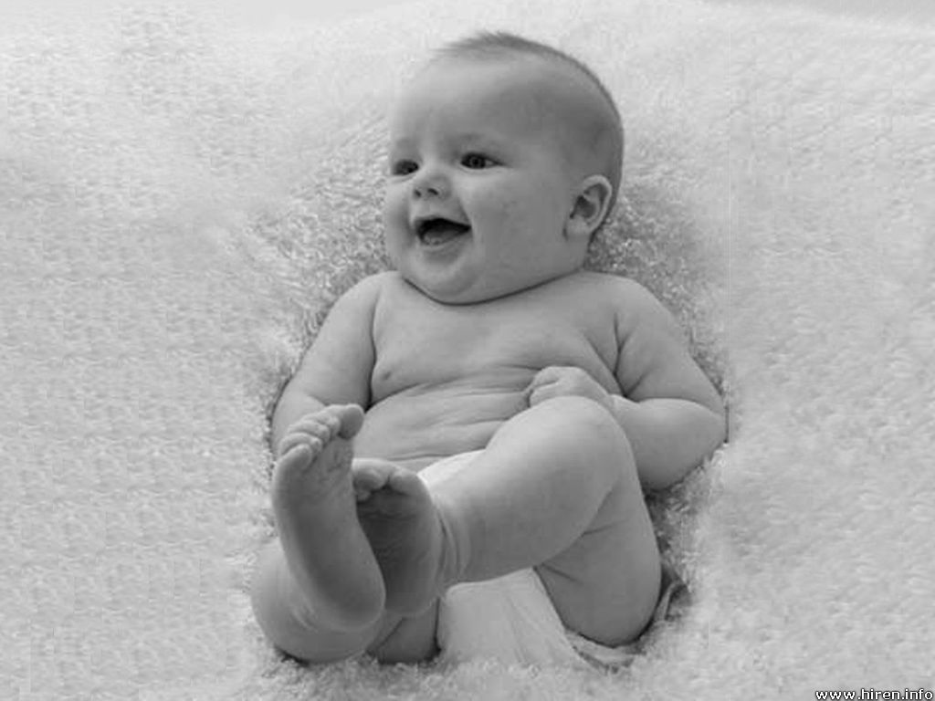
Sounds
The highest sound in the world must be ,
A violin being played by me.

The lowest sound in the world must be,
My Daddy singing a song to me.

The saddest sound in the world must me
Someone losing their front door key.

The happiest sound in the world must be
A baby giggling, don’t you agree?

By Rachel O’Brien

