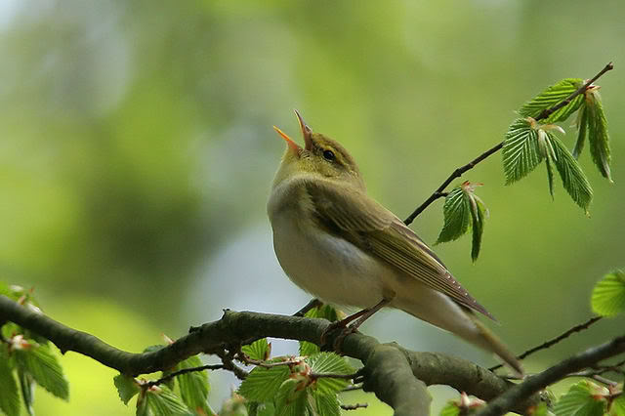
Sounds:

The silliest sound in the world must be
Corey talking normally.

The angrily sound in the world must be
My mom and dad shouting at me.

The loudest sound in the world must be
Third class talking constantly.

The nicest sound in the world must be
A bird singing in his tree .

By Rory Fanning

