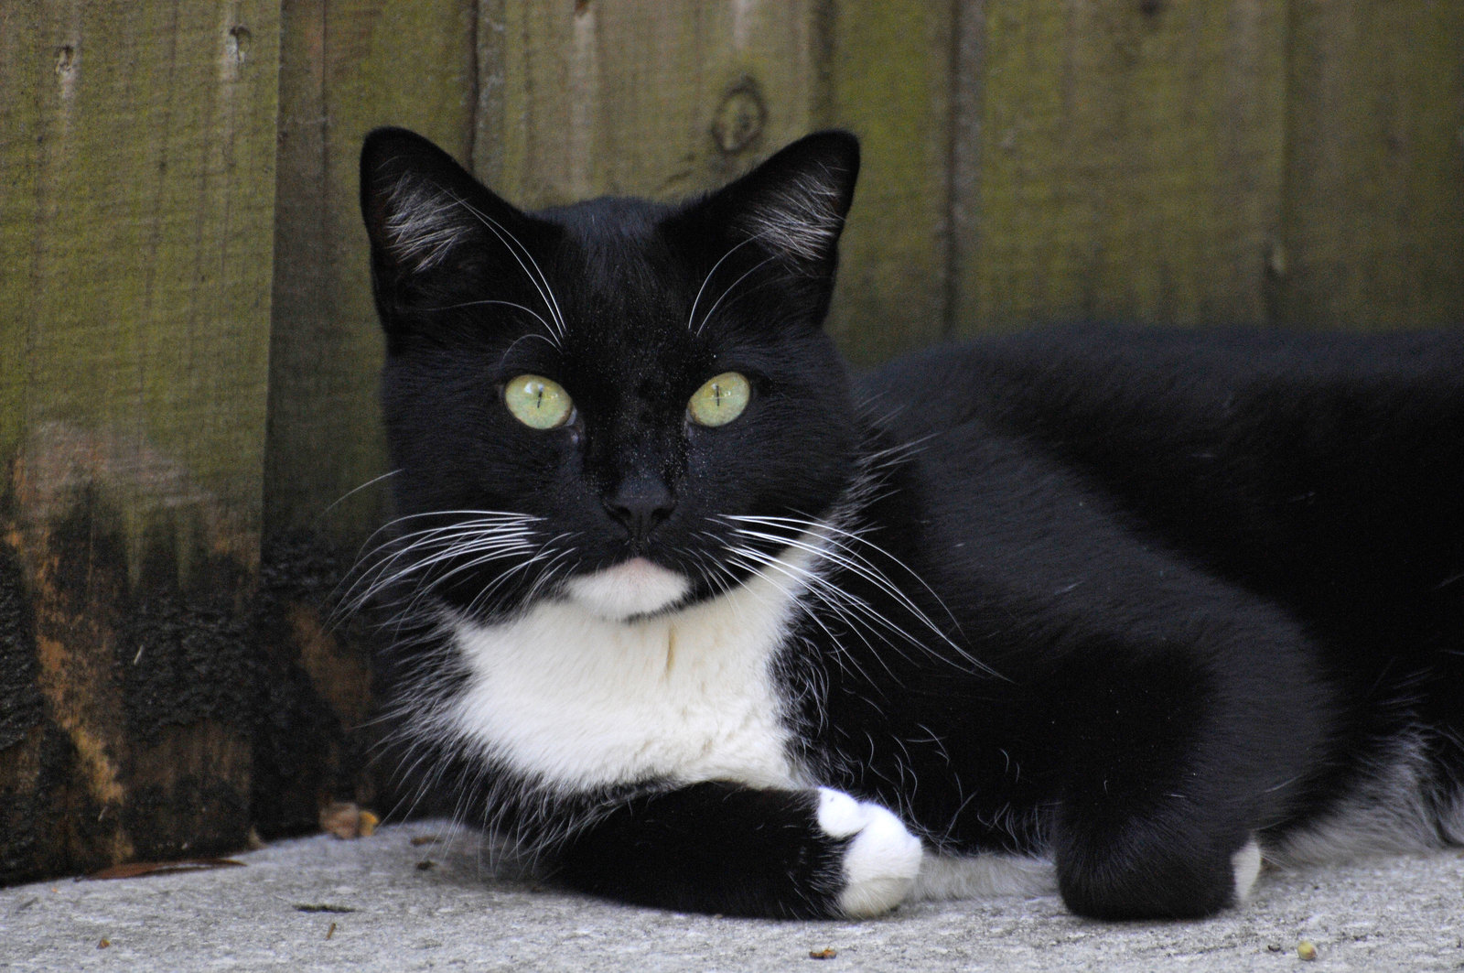
Sounds
The quickest sound in the world must be
Me getting home to drink my tea.

The funniest sound in the world must be
My cat trying to eat a pea!

The most annoying sound in the world must be
Third class talking over me.

The quietest sound in the world must be
People praying on one knee.

By: Sarah Nestor

