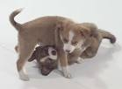
Sounds
The craziest sound in the world must be
Third class talking over me.

The jolliest sound in the world must be
Children playing happily.

The loudest sound in the world must be
Me and my friend playing the wii.

The jolliest sound in the world must be
A dog playing in a tree.

By Siobhán Kelly

