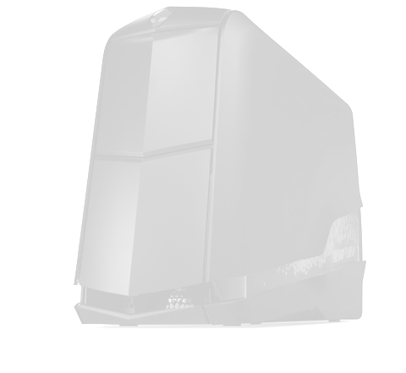
Computers

A new computer.
A cool new computer.
A custom cool new computer.
A huge custom cool new computer.
A gaming huge custom cool new computer.
A complicated gaming huge custom cool new computer.
A overpriced complicated gaming huge custom cool new computer.
A over clocked overpriced complicated gaming huge custom cool new computer.
A overpowered over clocked overpriced complicated gaming huge custom cool new computer.
A Monster Computer.

STEVEN HARDIMAN

