Our Volcano Experiment:
Team D: Ella, Emma, Lucy, Mary and Rachel.

Equipment:
- Baking soda
- Vinegar
- Paint (red and orange)
- Funnel
- Glass jar
- Jug
- Spoon (optional)

Method:
- Ella put the baking soda into the jar using the funnel.
- Rachel and Mary put the paint into the jar.
- Emma mixed the baking soda while Lucy poured in the vinegar.

Results:
The volcano erupted and we watched it.
There was a fizz and bubbles.

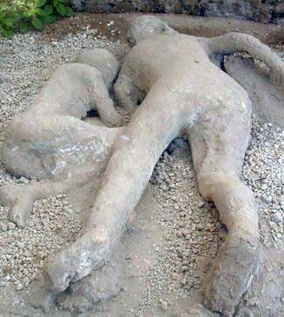

Facts on Pompeii:
- Pompeii was an ancient city in Southern Italy. The remains of the settlement are located near to Naples.
- The city of Pompeii was built at the foot of the volcano, Mount Vesuvius.
- Pompeii predates Roman rule. Historians think it was a settlement built by the Oscan civilization in about the 6th century BC .It was then controlled by the Samnites, before becoming a Roman city in about 80 BC.
- The city grew over the years and the original wooden buildings were slowly replaced with structures of brick and stone.
- During the first century AD, Pompeii was developing into a flourishing city port. It was a prosperous resort for numerous wealthy visitors. It contained many Roman villas, an amphitheatre, two theatres, several In 62 AD a severe earthquakes did a significant amount of damage to Pompeii’s buildings. It took several years to rebuild the city after the damage and many of the residents relocated to other Roman cities.
- Mount Vesuvius erupted in 79 AD. The eruption buried the city under volcanic ashes and cinders and exposed the city’s 20,000 inhabitants to blasts of hot air with temperatures of up to 250degrees C, easily hot enough to kill even those people who were sheltering inside stone buildings.
- temples and an aqueduct system.

